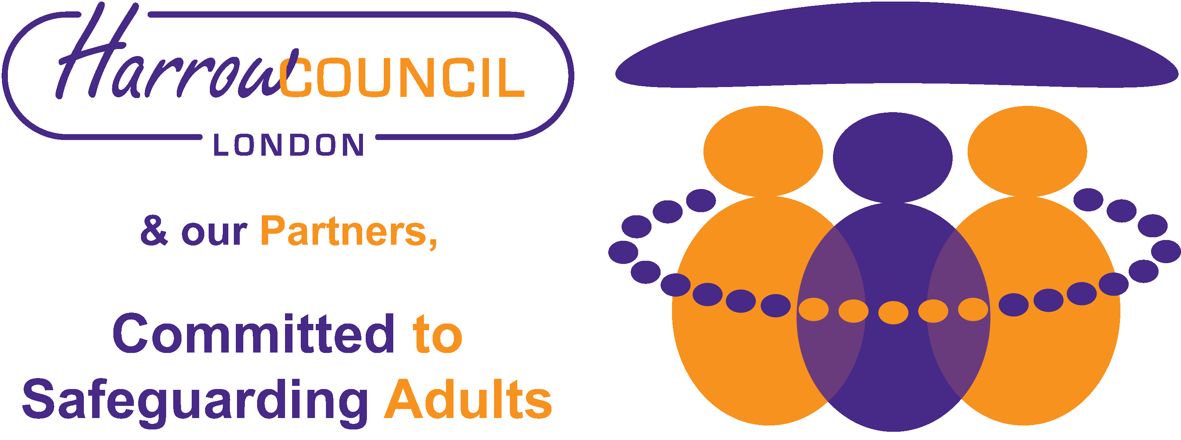
Protocol for Responding to Actual or Suspected Indecent Imagery (non-school version*)

Introduction

Under the Protection of Children Act 1978 (as amended), the UK has a strict prohibition on the taking, making, circulation, and possession with a view to distribution of any indecent photograph or pseudo photograph of a child and such offences carry a maximum sentence of 10 years’ imprisonment.

The term ‘making’ can include: opening an attachment to an email containing an image; downloading an image onto a computer screen; storing an image in a directory on a computer; accessing a website in which images appeared by way of an automatic ‘pop up’ mechanism.

Section 160 of the Criminal Justice Act 1988 also makes the simple possession of indecent photographs or pseudo photographs of children an offence and carries a maximum sentence of 5 years’ imprisonment.

‘Indecent’ is not defined in legislation. For most purposes, if imagery (moving or still) contains a naked young person, a topless girl, and/or displays genitals or sex acts, including masturbation, then it will be considered indecent. Indecent images may also include overtly sexual images of young people in their underwear.

What to do if a child or service user discloses receiving or seeing an actual or suspected indecent image

It is critically important that you follow correct safeguarding procedures. If you view or download an indecent image, even with the intention of confirming or securing evidence, you could be placing yourself at risk of committing a serious criminal offence and find yourself subject to the penalties described above. If convicted, you also face the likelihood of losing of your job and a future ban on working with children and vulnerable groups.

- Responding to indecent images on your ICT

- Do not take a screen shot - If you are using a mobile app, write down the name of the profile/user who has posted the image – or if you are using a web browser, copy the page address from the bar at the top of the screen. Then close it down.
- If ,the images are of an unknown child or children report the image to the Internet Watch Foundation www.report.iwf.org.uk/en using their step by step form to report what you have seen. They will decide if it might be illegal and if so, they will report it to the relevant police force.
- If the images are of a known child or you can tell that the images were taken locally, then you must notify the police directly. A referral should also be made to the MASH by or in consultation with your organisation’s Safeguarding Lead.
- Always notify your Safeguarding Lead Person

- Responding to a child or service user disclosing or reporting that they have received an indecent image

- Do not view the image yourself
- Do not send or print the image
- Do not delete the image
- Do not search the mobile device for other material

If you have reason to believe without looking that there are indecent images on a personal mobile device:

- You must inform your Safeguarding Lead Person
- Your Lead Safeguarding Person will notify the police and safeguarding services where applicable
- If you have viewed the images accidentally e.g. child or service user shows you without warning, you must inform your Safeguarding Lead Person of this happening.

If the imagery has been shared across your organisation’s network, a website or a social network:
- Notify the person responsible for network/website security in order to block the network to all users and isolate the imagery
- Notify your Safeguarding Lead Person

ACTIONS FOR YOUR ORGANISATION’S LEAD PERSON FOR SAFEGUARDING
The Safeguarding Lead Person may need to seek clarification of a disclosure or allegation after they have been made aware of the concern, but they should not view the imagery or conduct an investigation. Full notes of the incident must be made. Seeking clarification may involve:
- Identifying, without looking, what the image contains and whether anyone else has been involved.
- Finding out who has seen or shared the image and how further distribution can be prevented.
- Immediately refer the incident to the police
- Also refer to Adult Safeguarding (insert) or the MASH (insert) if the incident involves a child/young person or vulnerable adult

*Separate guidance is available for schools on the HSCB/Harrow Safeguarding Partnership’s website: www.harrowscb.co.uk

